Data Science with Python (Beginner)

**Course Structure**

Python Basics

* Installation of Python
* Variables in Python
* Numbers
* Strings
* Lists
* Dictionaries and Tuples
* Numpy Basics
* Pandas dataframe
* File handling (excel, csv)
* If Statement
* For loop
* Functions
* Matplotlib

Basic Statistics

* Mean, Median, Mode
* Standard deviation, Variance
* Probability
* Hypothesis testing
* Linear Regression
* Logistic regression
* Clustering

With 3-4 data science projects

Advantages of Python

1. Easy to learn and remember syntax, compact code
2. Interpretated language doesn’t have any compilation, due to this code development speed is 5 times fast compare to C, C++, java
3. Rich set of libraries: Library to everything
4. Open source: we can look on code
5. Python is used data science, end to end development for enterprise systems e.g. Youtube, surveymonkey, dropbox etc..
6. Lot of job opportunities

Python Installation

Python: <https://www.python.org/downloads/>

While installation click on Add Python to Path

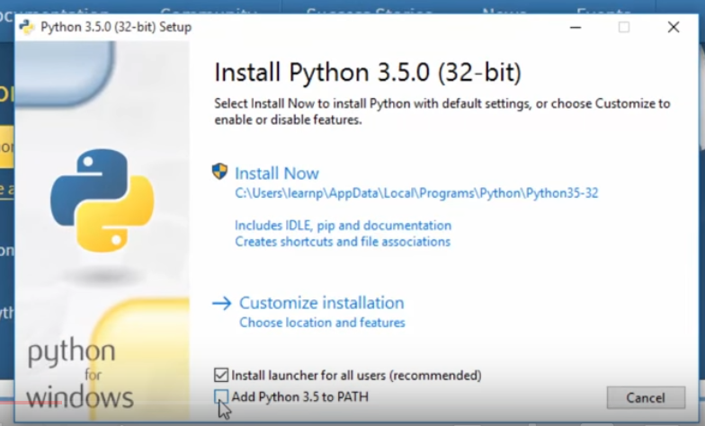

For successful installation search for ‘idle’ in window search, it will open Python Shell

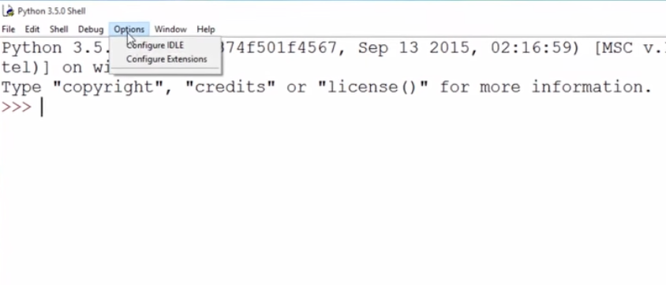

Python IDE : <https://www.spyder-ide.org/>

IDE : An **integrated development environment** is software for building applications that combines common developer tools into a single graphical user interface (GUI).

**Variables**

Are containers that can hold any type data numeric, string

**individual**